Placement Provider form upload

## Introduction

This document is dedicated to the placement provider form upload page manual. By using this page, the placement provider may upload their completed form and receive feedback on the success or failure of the upload. Companies may use the links on the page to either download the form, if they don’t have it, or redirect them to the online form to complete.

## Accessing the page.

Figure 1

As shown in Figure 1, companies may see this page by accessing the following link form: domain_name/newCompanyUpload. Note that this link may be changed in the future . This page provides all features and necessary information for placement providers to upload or download their forms or redirect to the online form.

## Selecting and uploading a form:

Figure 2

Figure 3

Figure 2 demonstrates the section where the company may upload or download their form. By clicking on the “browse files” button, as seen in Figure 3, a window will open. This window will let the user to choose their form location. Once chosen the user may submit the file by pressing the submit button. By pressing the download a copy of the form to complete will automatically be downloaded on the user’s computer.

## Upload state message

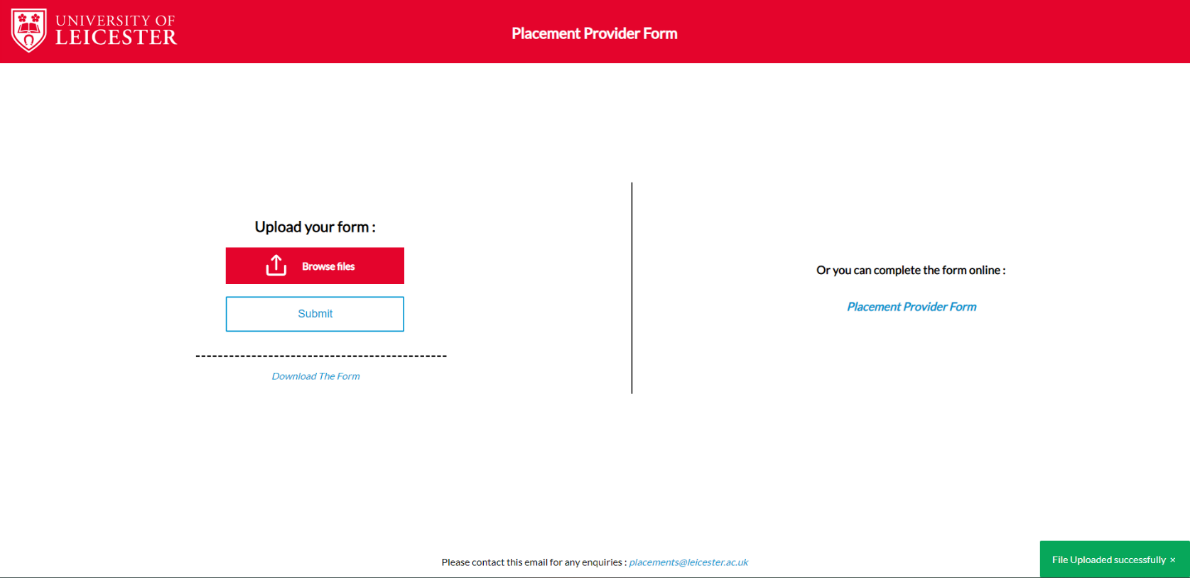

Figure 4

Figure 5

After the form is uploaded, a status message will appear on the bottom right of the page describing the status of the upload (**successful** *as seen on Figure 4* or **failure** *as seen on Figure 5).* The colour of the message also indicates this state**, Green** for **success** and **Red** for **failure**. Because the verification is included in a different user story, momentarily the failure may happen only if the file is not of a good format. This message will only disappear when the user presses the “X” button. This ensures that the user has enough time to see it.

## Enquiry team email:

At the bottom of the page, as shown in Figure 1, there is a link for the placements team’s email if the user has any enquiries about the form or the system.